EXPERIMENT NO :28

Design DFA using simulator to accept the string the end with ab over set {a,b)

W= abbaabab

AIM:

Design DFA using simulator to accept the string the end with ab over set {a,b)

W= abbaabab

INPUT :

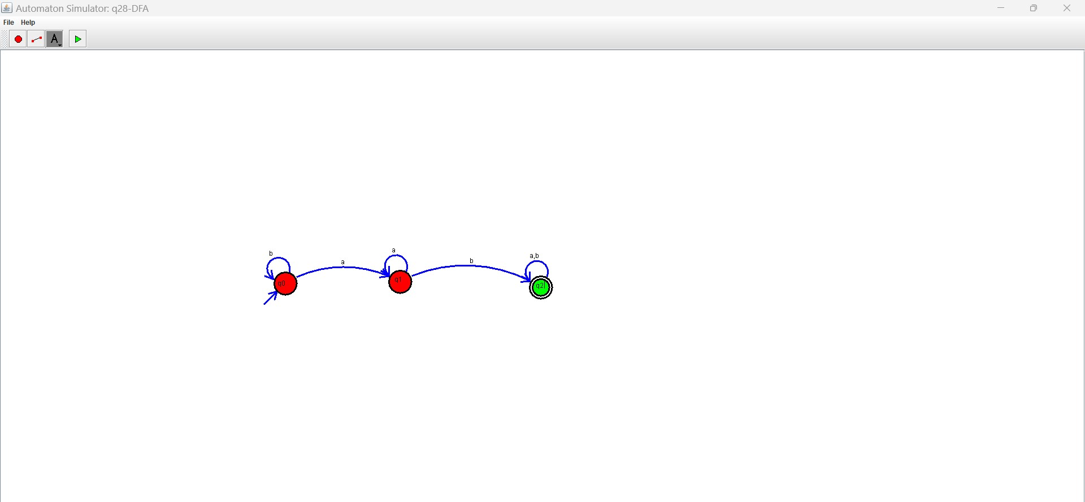

OUTPUT:

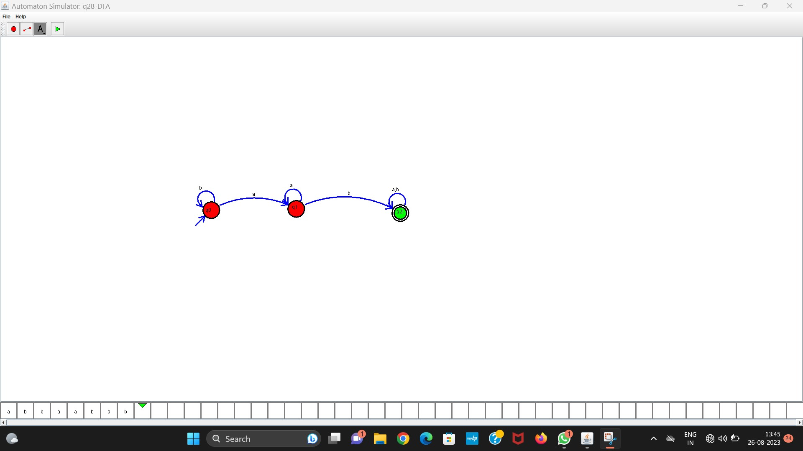

RESULT:

Thus the program was executed successfully